2.1.1 Roots of an Equation

Algorithm:
- Start.
- Read three space-separated integers a, b, and c.
- Calculate the discriminant.
D=b*b -4*a*c
- Check the value of discriminant.
- Case1: If D > 0 (Real and different roots)
Print: root1,root2.
- Case 2: If D == 0 (Real and same roots)
Print : root1=root2.
- Case 3: If D < 0 (Imaginary roots)
Print : Root = root 1 + imaginary
Root = root 2 + imaginary
- Stop.

Flowchart:
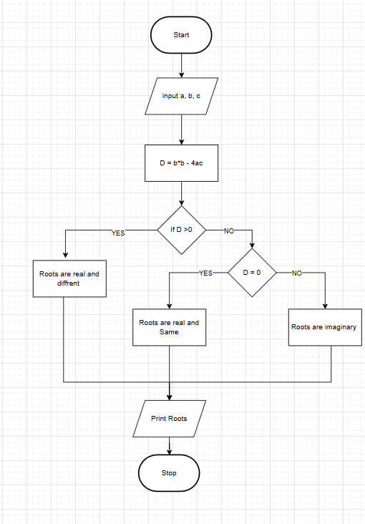

Code :
a, b, c = map(int,input().split())
d = (b*b) - 4 * a * c
sqrd = d** 0.5

if d > 0:
root1 = (-b + sqrd) / (2 * a)
root2 = (-b - sqrd) / (2 * a)
print(f"root1 = {root1:.2f}")
print(f"root2 = {root2:.2f}")
elif d == 0:
root = -b / (2 * a)
print(f"root1 = root2 = {root:.2f}")
else:
real_part = (-b) / (2 * a)
imaginary_part = sqrd / (2 * a)
print(f"root1 = {real_part.real:.2f}+{imaginary_part.imag:.2f}i")
print(f"root2 = {real_part.real:.2f}-{imaginary_part.imag:.2f}i")

Execution :
